|  |  |
| --- | --- |
| name | Doha Hashem Abd El Monem  ضحي هاشم عبد المنعم هاشم |
| Sec  group | 18  3 |
| Num setting | 406 |
| Report about | Programming Languages |
| GitHub Link | https://github.com/DohaHashem/ece001 |

Programming Languages You Should Learn in 2020

Programming languages and computer coding have made life simpler for us. Whether it’s automobiles, banks, home appliances, or hospitals, every aspect of our lives depends on codes. No wonder, coding is one of the core skills required by most well-paying jobs today. Coding skills are especially of value in the IT, data analytics, research, web designing, and engineering segments.

So, which programming languages will continue to be in demand in 2020 and beyond? How many languages should you know to [pursue your dream career](https://www.computer.org/publications/tech-news/trends/top-career-skills-to-land-in-your-dream-tech-companies)? We will attempt to answer these tricky questions in this post.

The ever-growing [list of programming languages](https://www.whoishostingthis.com/resources/programming/#list-of-coding-languages) and protocols can make it tough for programmers and developers to pick any one language that’s most suitable for their jobs or project at hand. Ideally, every programmer should have knowledge of a language that’s close to the system (C, Go, or C++), a language that’s object-oriented (Java or Python), a functional programming language (Scala), and a powerful scripting language (Python and JavaScript).

Whether you are aiming at joining a Fortune 500 firm or desire to pursue a [work-from-home career](https://budgetboost.co/pros-and-cons-of-being-a-work-at-home-programmer/) in programming, it’s important to know what’s hot in the industry. Here are a few programming languages we recommend for coders who want to make it big in 2020.

* **Types of programming languages :**

**1.  Python**

Python continues to be one of the best programming languages every developer should learn this year. The language is easy-to-learn and offers a clean and well-structured code, making it powerful enough to build a decent web application.

Python can be used for web and desktop applications, GUI-based desktop applications, machine learning, data science, and network servers. The programming language enjoys immense community support and offers several open-source libraries, frameworks, and modules that make application development a cakewalk.

For instance, Python offers Django and Flask, popular libraries for web development and TensorFlow, Keras, and SciPy for data science applications.

Though Python has been around for a while, it makes sense to learn this language in 2020 as it can help you get a job or a freelance project quickly, thereby accelerating your career growth.

**2.  Kotlin**

Kotlin is a general-purpose programming language with type inference. It is designed to be completely interoperable with Java. Moreover, from the time Android announced it as its first language, Kotlin offers features that developers ask for. It effortlessly combines object-oriented and functional programming features within it.

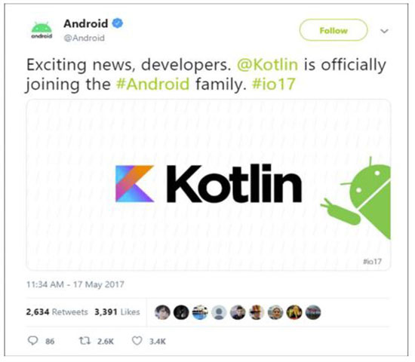

The effortless interoperation between Java and Kotlin makes Android development faster and enjoyable. Since Kotlin addresses the major issues surfaced in Java, several Java apps are rewritten in Kotlin. For instance, brands like Coursera and Pinterest have already moved to Kotlin due to strong tooling support.

As most businesses move to Kotlin, Google is bound to promote this language more than Java. Hence, Kotlin has a strong future in the Android app development ecosystem.

Kotlin is an easy-to-learn, open-source, and swift language for Android app development that removes any adoption-related barriers. You can use it for Android development, web development, desktop development, and server-side development. Therefore, it’s a must-learn language for programmers and Android app developers in 2020.

**3.  Java**

Java is celebrating its 24th birthday this year and has been one of the most popular programming languages used for developing server-side applications. Java is a practical choice for  developing Android apps as it can be used to create highly functional programs and platforms.

This object-oriented programming language does not require a specific hardware infrastructure, is easily manageable, and has a good level of security. Moreover, it is easier to learn Java in comparison to languages such as C and C++. No wonder, nearly [90 percent of Fortune 500 firms](https://www.infoworld.com/article/2687995/4-reasons-to-stick-with-java.html) rely on Java for their desktop applications and backend development projects.

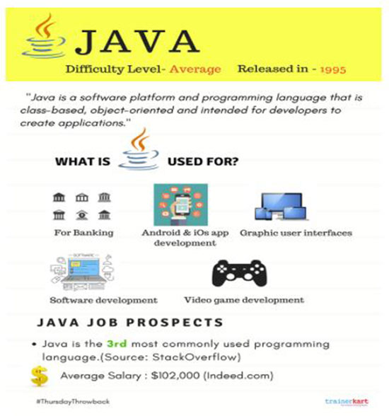

 Despite its industry age, the Java is incredibly stable and not heading for retirement anytime soon. This makes Java one of the most desirable languages among programmers in 2020.

**4.  JavaScript/ NodeJS**

JavaScript (also known as NodeJS) is a popular language among developers who need to work on server-side and client-side programming. It is compatible with several other programming languages, allowing you to create animations, set up buttons, and manage multimedia.

Owing to its high speed and regular annual updates, JavaScript is an ultimate hit in the IT domain. Reputed firms like Netflix, Uber, PayPal, and several startups use JavaScript to create dynamic web pages that are secure and fast. In fact, the [2018 Developer Skills Report](https://research.hackerrank.com/developer-skills/2018#skills2) by HackerRank shares that JavaScript is the top programming skill required by companies today.

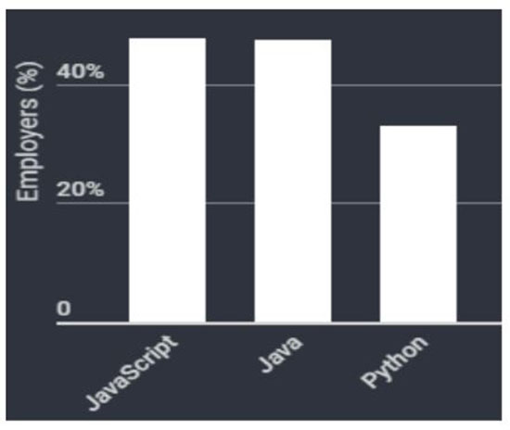

JavaScript is omnipresent in today’s digital environment. Hence, learning this language makes complete sense.

Screen Shoot :

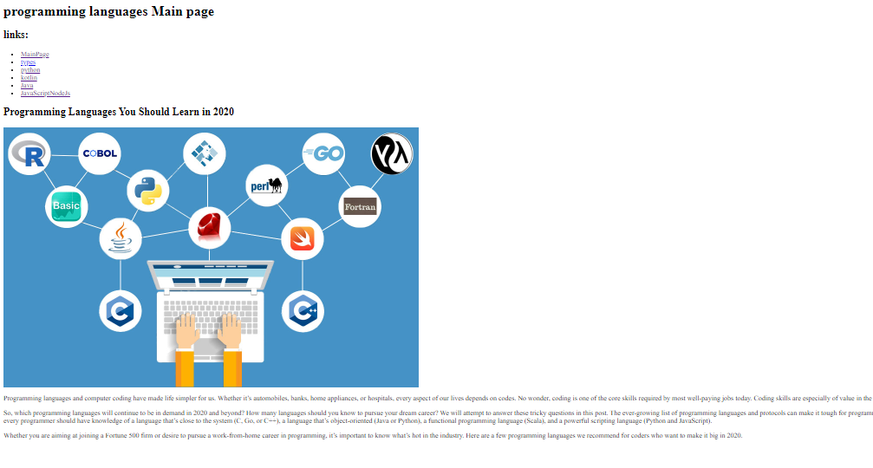

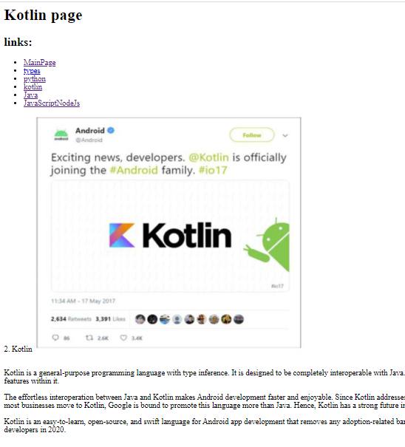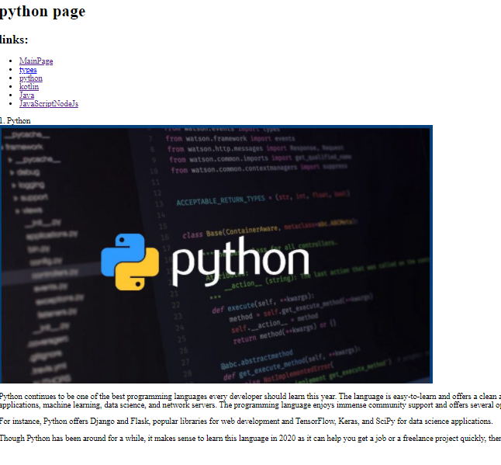

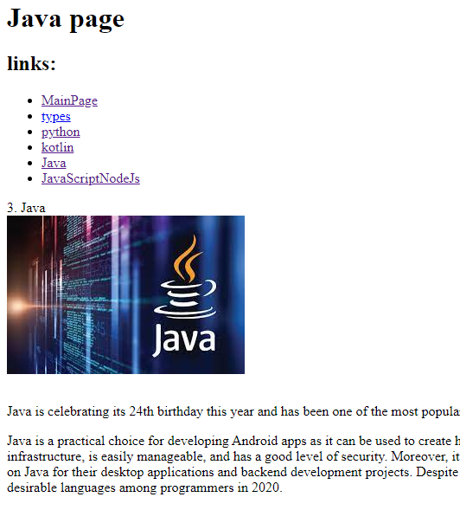

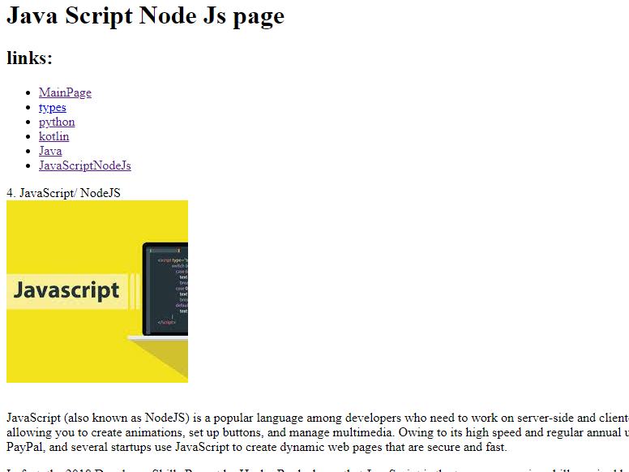

scours code :

